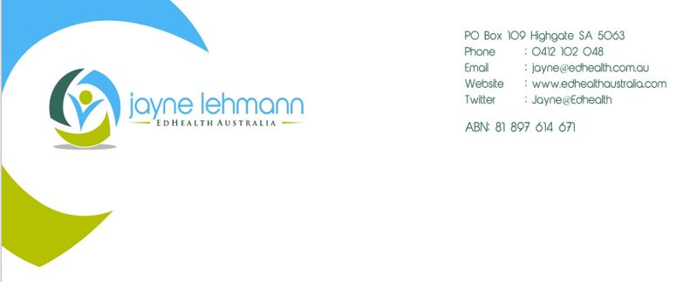Access to BGM strips restricted for people with diabetes not on insulin!
Credentialled Diabetes Educator assistance available!
People with type 2 diabetes not on insulin will have their access to blood glucose monitoring (BGM) strips restricted from 1st July 2016.

- BGM strips can be purchased from the NDSS for 6 months from the first purchase after 1st July 2016.

- Then they must see a Credentialled Diabetes Educator (CDE) or doctor for assessment of clinical need to continue to get blood glucose monitoring strips for the following 6 months. Many people will need 6 monthly review or an appointment arranged when clinical need changes.
As a CDE I can assess and approve BGM strip access under the NDSS changes. To save yourself time and paperwork, refer your patients with type 2 diabetes not using insulin to me, Jayne Lehmann. I have clinics in Malvern, Clovelly Park and Brighton.
Allocate 2 of the Chronic Disease Management appointments each year to people with diabetes not on insulin so I can help you out with the assessment and paperwork required.
At the same time, their BGM technique will be checked, I will teach them structured BGM and provide a Check, Think and Act resource to support a proactive approach to using their diabetes numbers to improve diabetes health. Unhealthy behaviours can be discussed to improve the impact of food, stress and exercise on their blood glucose levels. Those on a sulphonylureas receive education on hypoglycaemia management.
This approach complements rather than replaces the role of your Practice Nurse and means you don’t have to add another task to your busy consultations with people with diabetes. Don’t forget to also consider referring those on insulin as well!
Referrals can be sent via fax to Jayne Lehmann, Fax: 8271 0947.
Regards
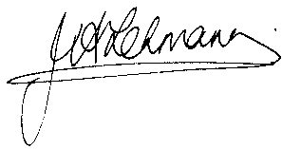
Jayne Lehmann RN CDE
Credentialled Diabetes Educator

